DS LAB 7
Example 1:
#include <iostream>

using namespace std;

const int MAX=100; // size of stack

class Stack{
int top;
public:
int a[MAX];

Stack(){
top = -1;
}

bool push(int x);

int pop();
int peek();
bool isEmpty();
};

bool Stack:: push(int x){
if(top>=(MAX-1)){
cout<<"Stack overflow"<<endl;
return false;
}
else{
a[++top] = x;
cout<<x<<" "<<endl;
return true;
}
}
int Stack::pop(){
if(top<0){
cout<<"Stack underflow"<<endl;
return 0;
}
else{
int x = top--;
cout<<a[x]<<endl;
return x;
}
}

int main(){
Stack s1;

int arr[10] = {123,124,53,46,21,44,112,34,21,89};

for (int i =0;i<10;i++){
s1.push(arr[i]);
}
cout<<"Now reverse:" << endl;

for(int j =0 ; j<10;j++){
s1.pop();
}
return 0;
}
OUTPUT:
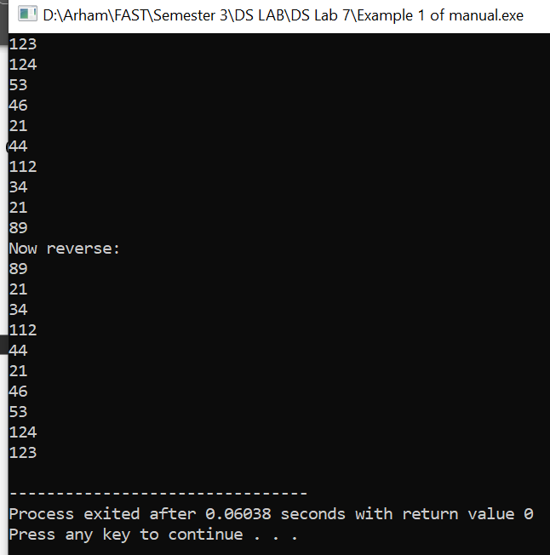

TASK 1:
#include <iostream>
#include <cstring>

using namespace std;

class Stack {
private:
char stckArr[100]; // Array to store the stack
int top; // Index of the top element

public:
Stack() {
top = -1; // Initialize top to -1 (empty stack)
}

void push(char value) {
if (top < 99) {
stckArr[++top] = value; // Push the value onto the stack
}
}

char pop() {
if (top >= 0) {
return stckArr[top--]; // Pop the top element from the stack
}
return '\0'; // Return null character if stack is empty
}

bool isEmpty() {
return top == -1;
}
};

int main() {
Stack st1;
const char* givInput = "BORROWROB";
cout<<givInput<<endl;
int inpLength = strlen(givInput);

for (int i = 0; i < inpLength; i++) {
st1.push(givInput[i]);
}

bool palindCheck = true;
for (int i = 0; i < inpLength; i++) {
if (st1.pop() != givInput[i]) {
palindCheck = false;
break;
}
}

if (palindCheck) {
cout << "Yay!! The string is a palindrome." << endl;
} else {
cout << "Aww! The string is not a palindrome." << endl;
}

return 0;
}
OUTPUT:
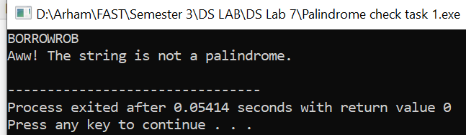

TASK 2:
#include <iostream>
using namespace std;

const int capacty = 10;

class Queue {
private:
int itemsinQueue[capacty];
int front;
int rear;
public:
Queue();
bool isFull();
bool isEmpty();
void enqueue(int item);
int dequeue();
void display();
};

Queue::Queue() {
front = -1;
rear = -1;
}

bool Queue::isFull() {
if (rear == capacty - 1) {
return true;
}
else {
return false;
}
}

bool Queue::isEmpty() {
if (front == -1 || front > rear) {
return true;
}
else {
return false;
}
}

void Queue::enqueue(int item) {
if (isFull()) {
cout << "Queue is full, cannot add more items." << endl;
}
else {
if (front == -1) {
front = 0;
}
rear++;
itemsinQueue[rear] = item;
}
}

int Queue::dequeue() {
int item;
if (isEmpty()) {
cout << "Queue is empty, cannot remove further." << endl;
return -1;
}
else {
item = itemsinQueue[front];
front++;
return item;
}
}

void Queue::display() {
if (isEmpty()) {
cout << "Queue is empty, kuch nhi display krne ko." << endl;
}
else {
cout << "The queue elements are: " << endl;
for (int i = front; i <= rear; i++) {
cout << itemsinQueue[i] << " ";
}
cout << endl;
}
}

int main() {
Queue qu1;
int customerIDs[] = {13, 7, 4, 1, 6, 8, 10};

for (int i = 0; i < 7; i++) {
qu1.enqueue(customerIDs[i]);
}

qu1.display();

// dequeuing each customer ID one by one as they are checked out by the cashier
while (!qu1.isEmpty()) {
int id = qu1.dequeue(); // Dequeue and storing the customer ID
cout << "Checking out customer ID: " << id << endl;
}

qu1.display();

return 0;
}
OUTPUT:
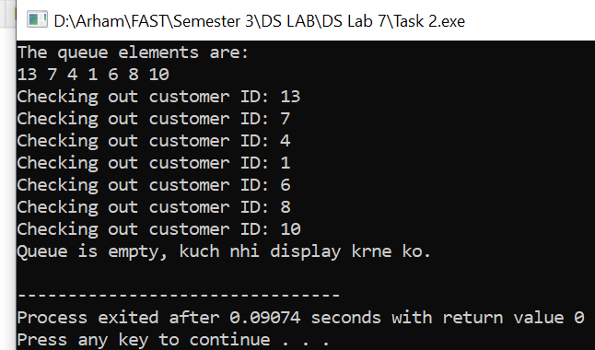

TASK 3: (Result is 21. Not 20)
#include <iostream>
#include <string>
#include <stack>
#include <cctype>
using namespace std;

// Doubly linked list
struct Node {
char data;
Node* next;
Node* prev;
Node(char c) : data(c), next(nullptr), prev(nullptr) {}
};

class LinkedList {
private:
Node* top;

public:
LinkedList() : top(nullptr) {}

void push(char c) {
Node* newNode = new Node(c);
if (top == nullptr) {
top = newNode;
} else {
newNode->next = top;
top->prev = newNode;
top = newNode;
}
}

char pop() {
if (top == nullptr) {
cerr << "Stack is empty!" << endl;
return '\0';
}
char data = top->data;
Node* temp = top;
top = top->next;
delete temp;
return data;
}

char peek() {
if (top == nullptr) {
cerr << "Stack is empty!" << endl;
return '\0';
}
return top->data;
}

bool isEmpty() {
return top == nullptr;
}
};

int evaluateExpression(const string& expression) {
stack<int> values;
stack<char> operators;
size_t i = 0;

for (char c : expression) {
if (c == ' ') {
continue;
} else if (isdigit(c)) {
int num = 0;
while (isdigit(c)) {
num = num * 10 + (c - '0');
c = expression[++i];
}
values.push(num);
} else if (c == '(') {
operators.push(c);
} else if (c == ')') {
while (!operators.empty() && operators.top() != '(') {
int b = values.top();
values.pop();
int a = values.top();
values.pop();
char op = operators.top();
operators.pop();
if (op == '+') {
values.push(a + b);
} else if (op == '-') {
values.push(a - b);
}
}
operators.pop(); // Remove the '('
} else if (c == '+' || c == '-' || c == '*' || c == '/') {
while (!operators.empty() && operators.top() != '(' && ((c == '+' || c == '-') && (operators.top() == '*' || operators.top() == '/'))) {
int b = values.top();
values.pop();
int a = values.top();
values.pop();
char op = operators.top();
operators.pop();
if (op == '+') {
values.push(a + b);
} else if (op == '-') {
values.push(a - b);
} else if (op == '*') {
values.push(a * b);
} else if (op == '/') {
values.push(a / b);
}
}
operators.push(c);
}
}

while (!operators.empty()) {
int b = values.top();
values.pop();
int a = values.top();
values.pop();
char op = operators.top();
operators.pop();
if (op == '+') {
values.push(a + b);
} else if (op == '-') {
values.push(a - b);
} else if (op == '*') {
values.push(a * b);
} else if (op == '/') {
values.push(a / b);
}
}

return values.top();
}

int main() {
string expression = "x=12+13-5*(0.5+0.5)+1";

LinkedList st1;
string postfixExpression;

for (char c : expression) {
if (c == ' ') {
continue;
}

if (c == '=') {
// Push '=' onto the stack
st1.push(c);
} else if (c == 'x') {

st1.push(c);
} else {

while (!st1.isEmpty() && (st1.peek() == '+' || st1.peek() == '-' || st1.peek() == '(') &&
(c == '*' || c == '/')) {
st1.push(c);
break;
}
st1.push(c);
}

postfixExpression += c;
}

cout << "Stack contents: ";
while (!st1.isEmpty()) {
cout << st1.pop();
}
cout << endl;

return 0;
}
OUTPUT:
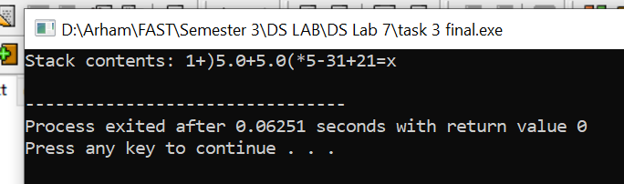

TASK4 (Q5):
Strange Question!!

